
CS 104L – Introduction to Cybersecurity
Assignment # 01
Live Traffic Capture and Analysis with Wireshark

––
Student Name: Athar Imran
Student ID: 2604277

Assignment Date: th October, 2026
Assignment done: th October, 2026
Due Date: th October, 2026

Contents
Task 1: Capture Details 3
Task 2: Protocols 4
Task 3: DNS 5
Task 4: HTTP vs HTTPS 8
Task 5: TCP Handshake 11
Task 6: Privacy and Protection 12

Task 1: Capture Details
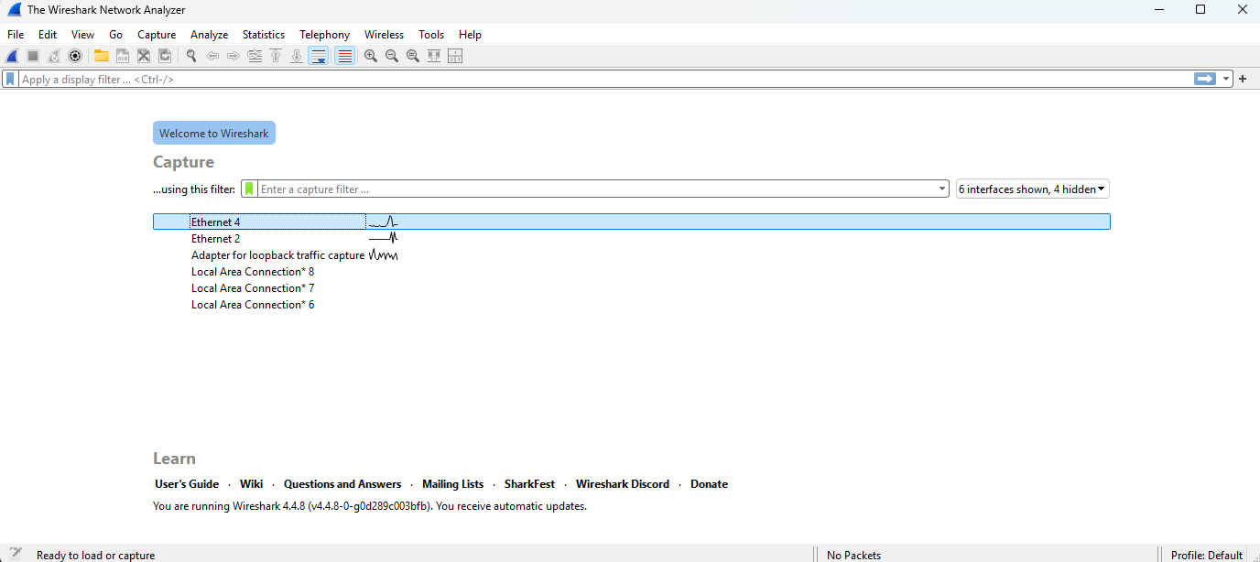
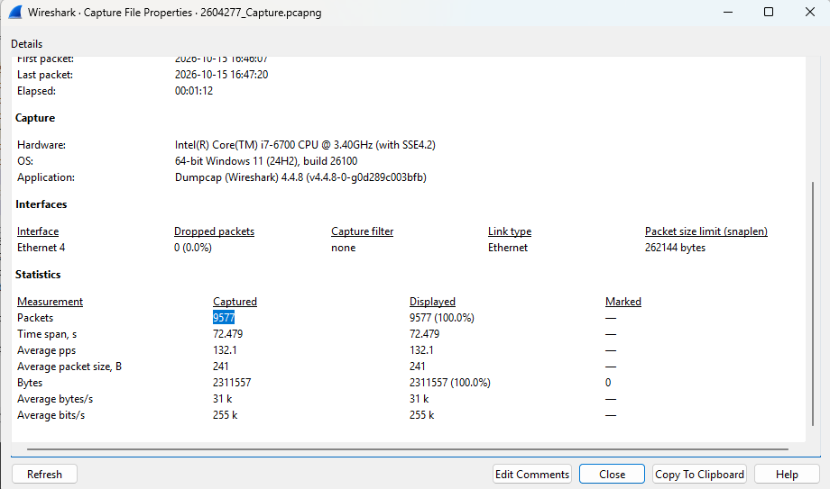
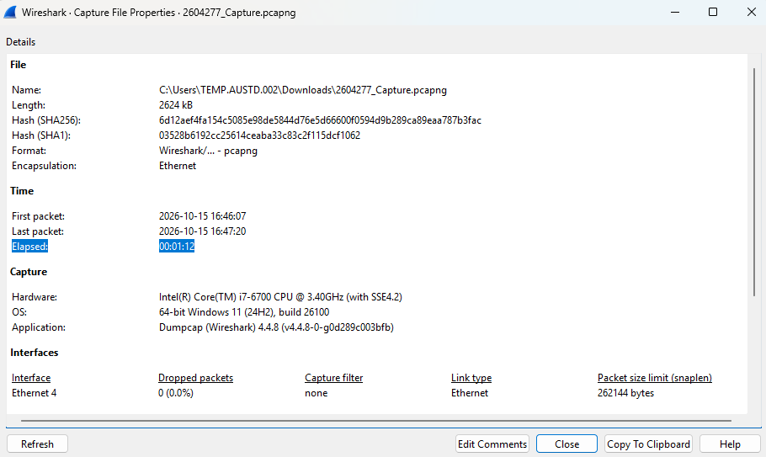

Task 2: Protocols
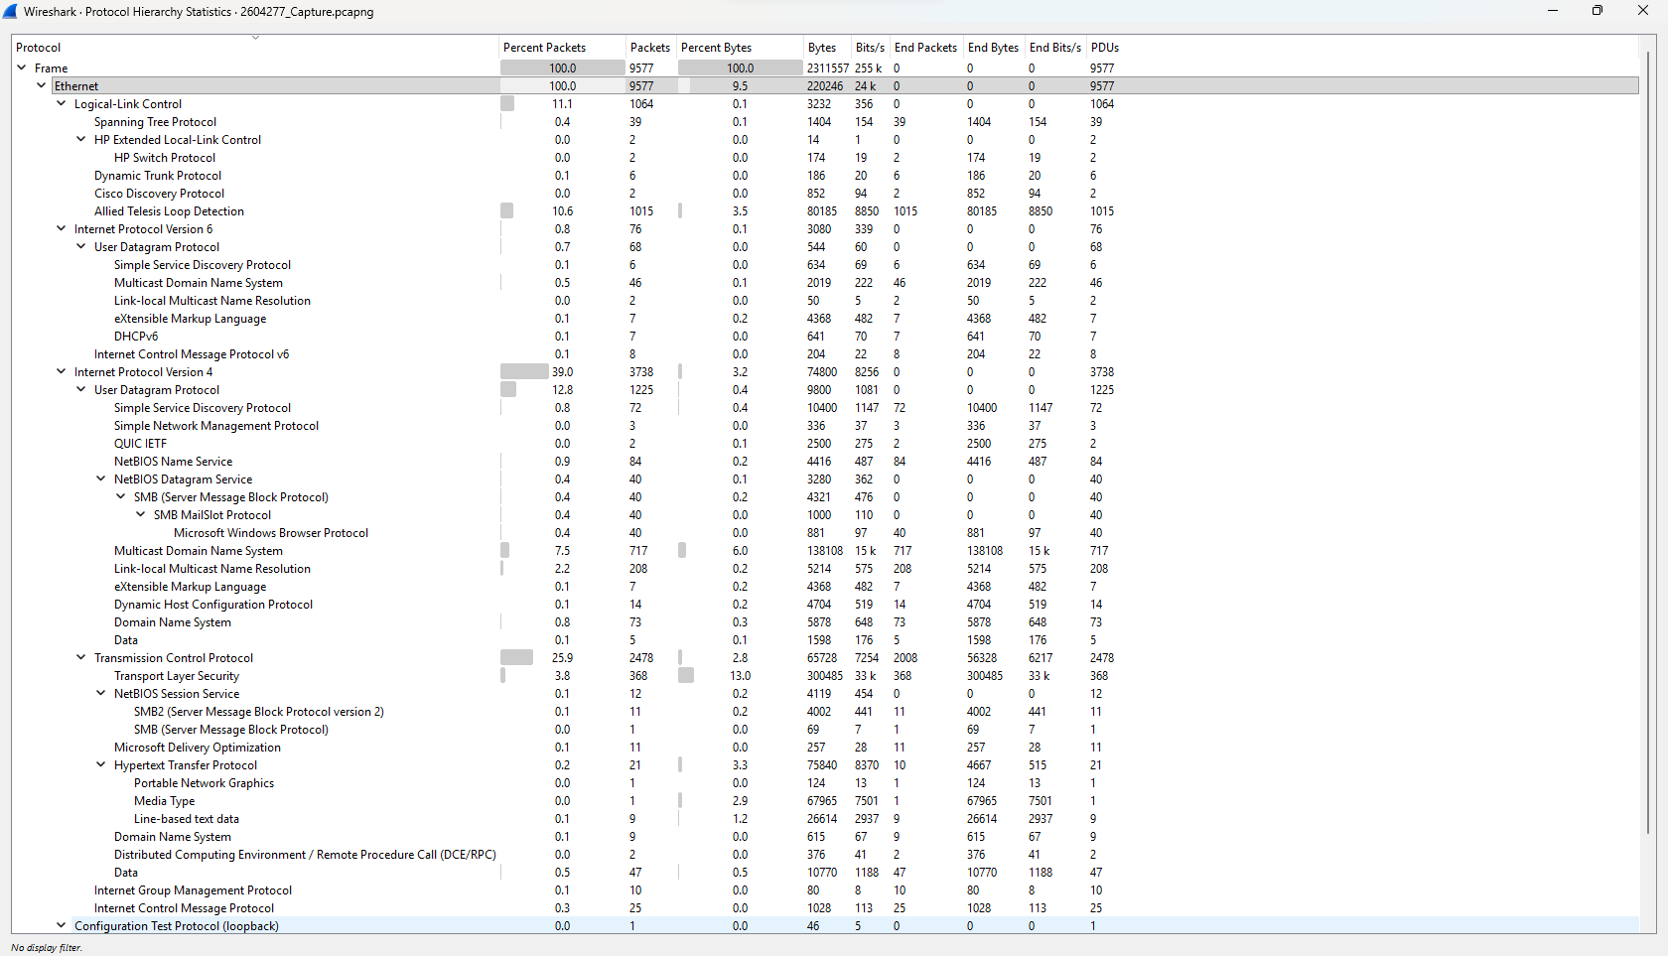
Rank | Protocol | Percent Packets
1 | Address Resolution Protocol (ARP) | 49.06%
2 | Internet Protocol Version 4 (IPv4) | 39.03%
3 | Transmission Control Protocol (TCP) | 25.87%
4 | User Datagram Protocol (UDP) | 12.79%
5 | Allied Telesis Loop Detection | 10.60%

Protocol | Layer | Purpose |  | Packet no.
ARP | Data Link (Layer 2) | Maps an IPv4 address to a MAC address on a local network. |  | 1
DNS | Application (Layer 7) | Translates domain names into IP addresses. |  | 10
TCP | Transport (Layer 4) | Provides reliable, ordered data delivery between devices. |  | 20
HTTP | Application (Layer 7) | Transfers web pages and other web content between clients and servers. |  | 30

Task 3: DNS
DNS – Domain Name System, protocol translates website domain names into IP addresses so our computer can locate the correct server and we humans can easily understand websites address in common language, instead of remembering IP address.
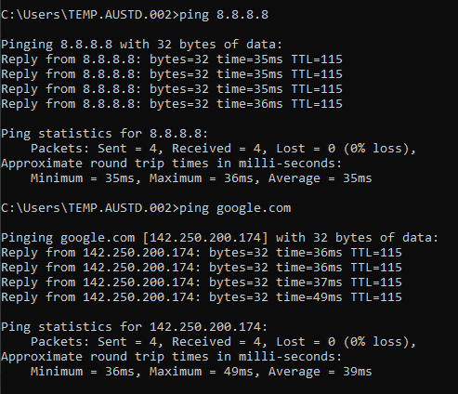
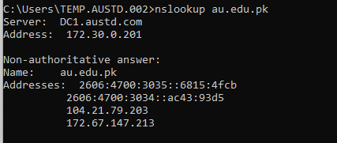
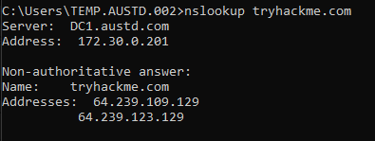
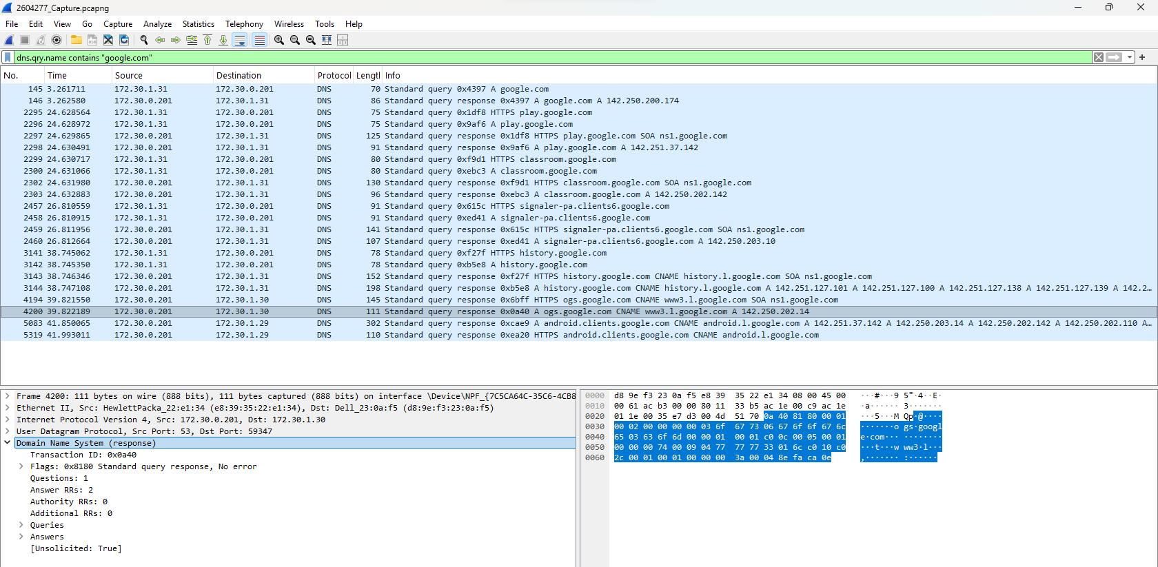
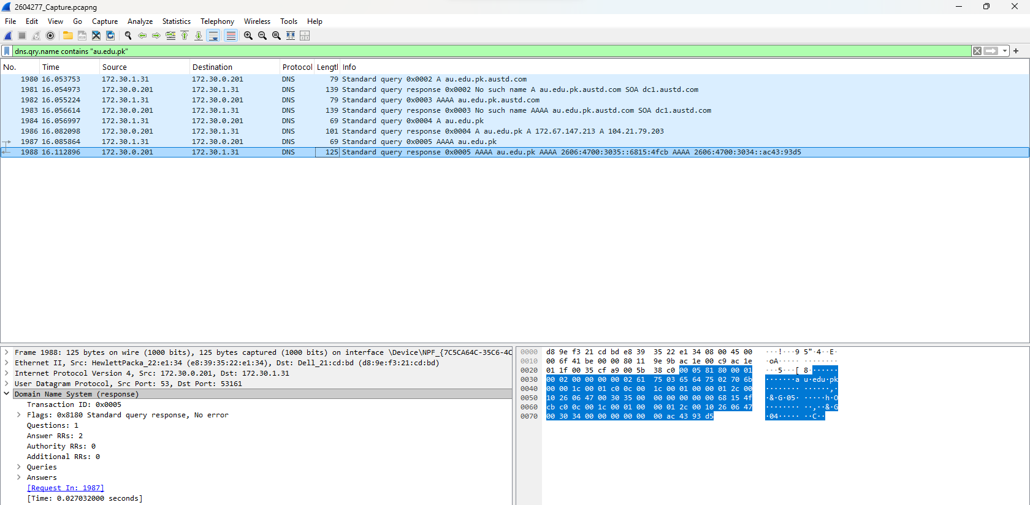
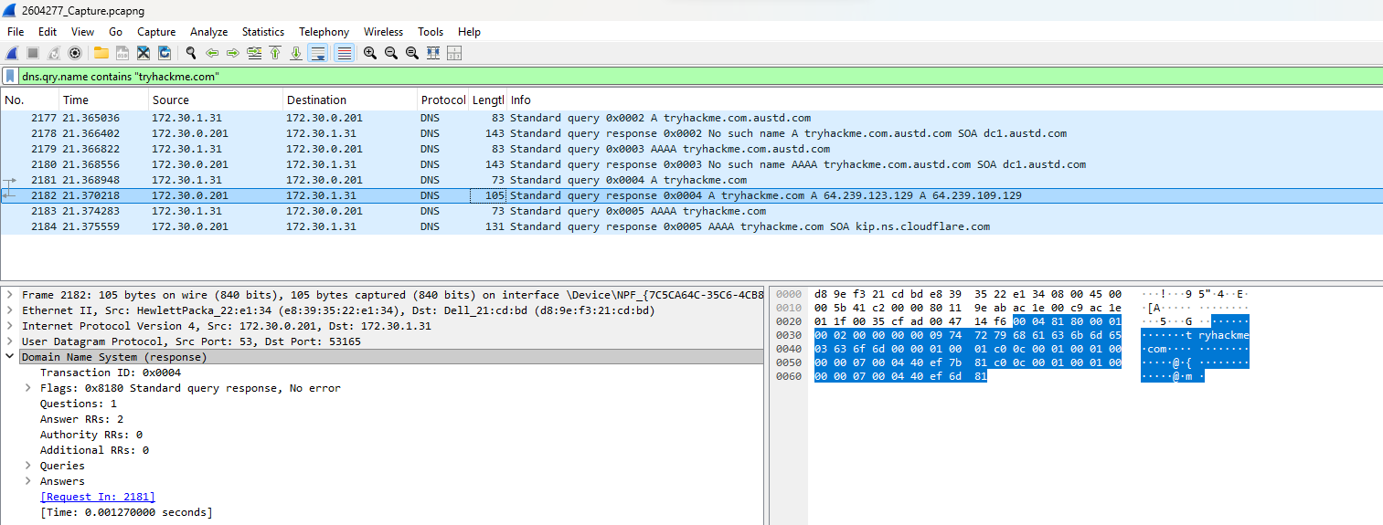
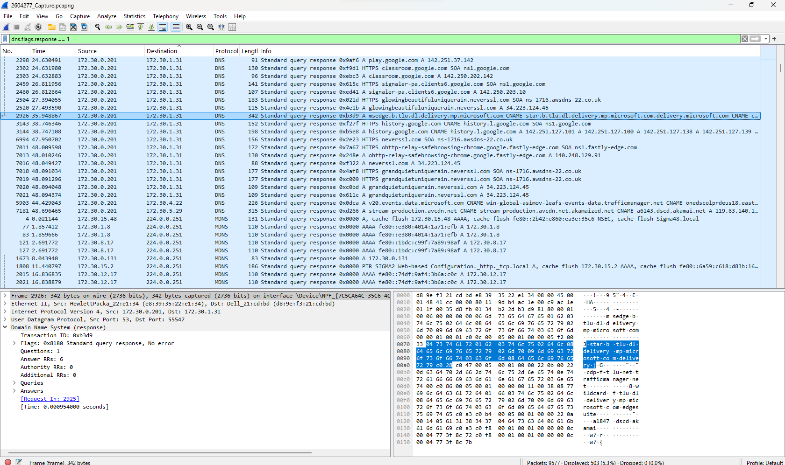
This appears to be a Microsoft Edge delivery or update server. It may be used to download browser components or updates automatically in the background.

Task 4: HTTP vs HTTPS
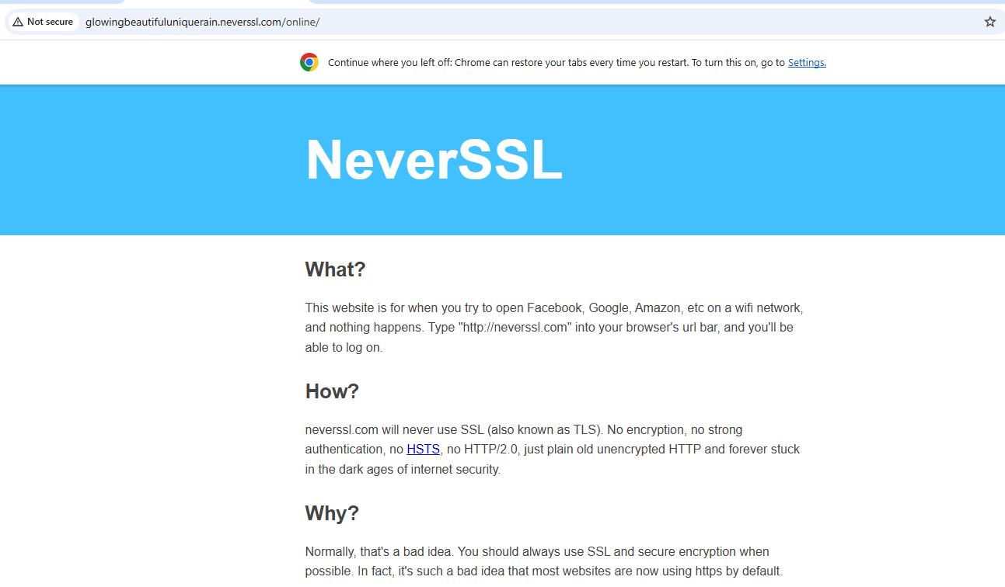
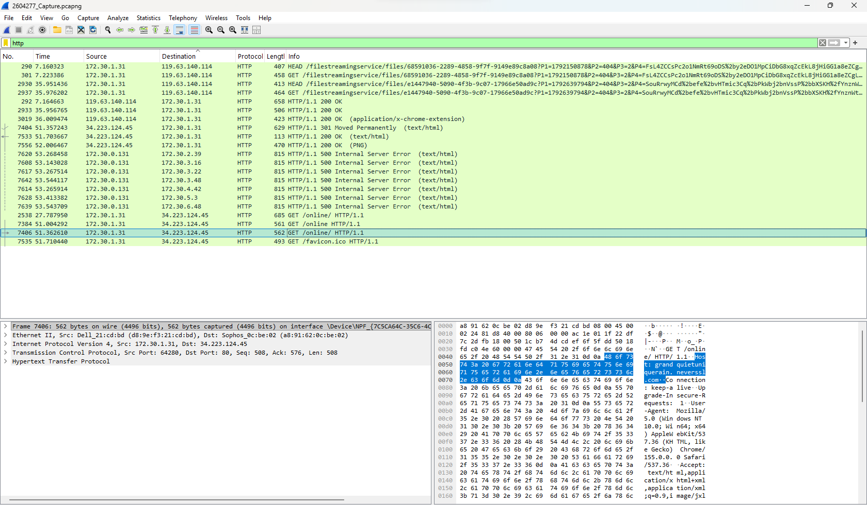
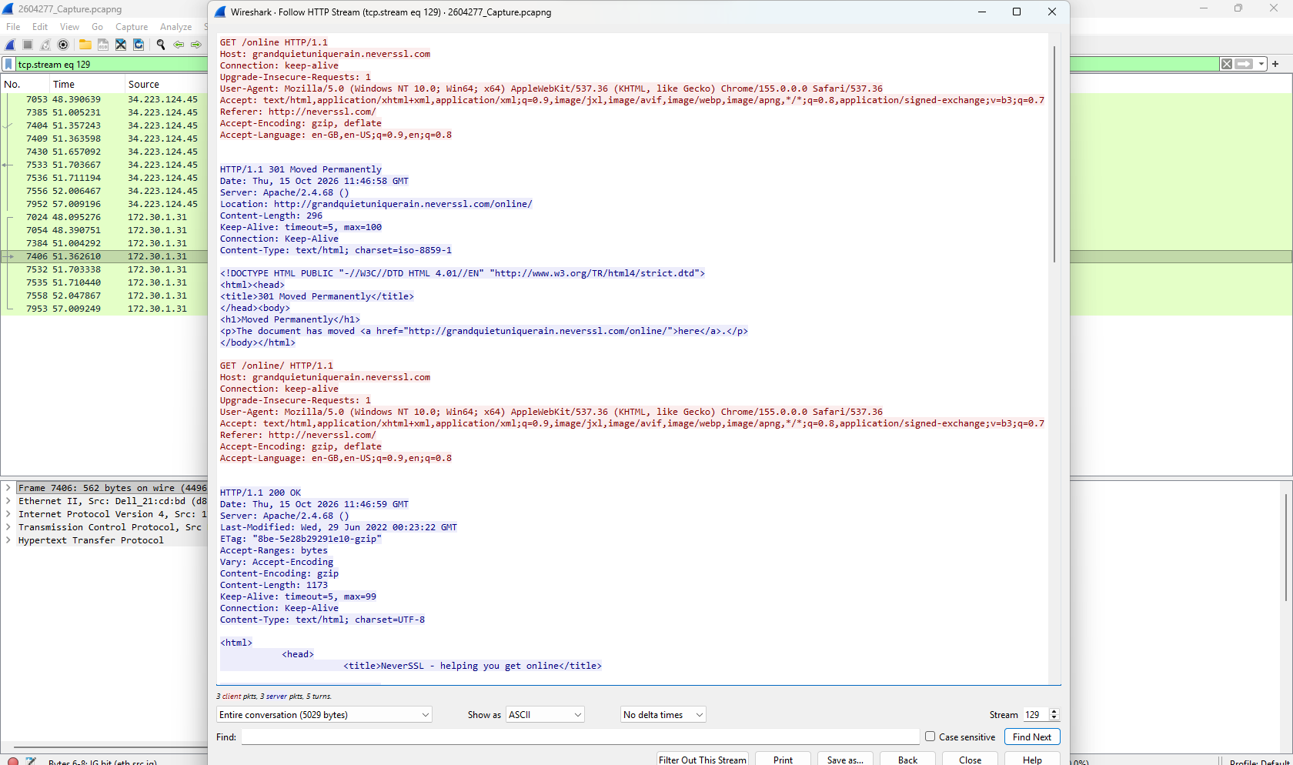
Field | Value from capture
Request | GET /online/ HTTP/1.1
Host | glowingbeautifuluniquerain.neverssl.com
Server ip | 34.223.124.45
User-agent | Mozilla/5.0 (Windows NT 10.0; Win64; x64) AppleWebKit/...

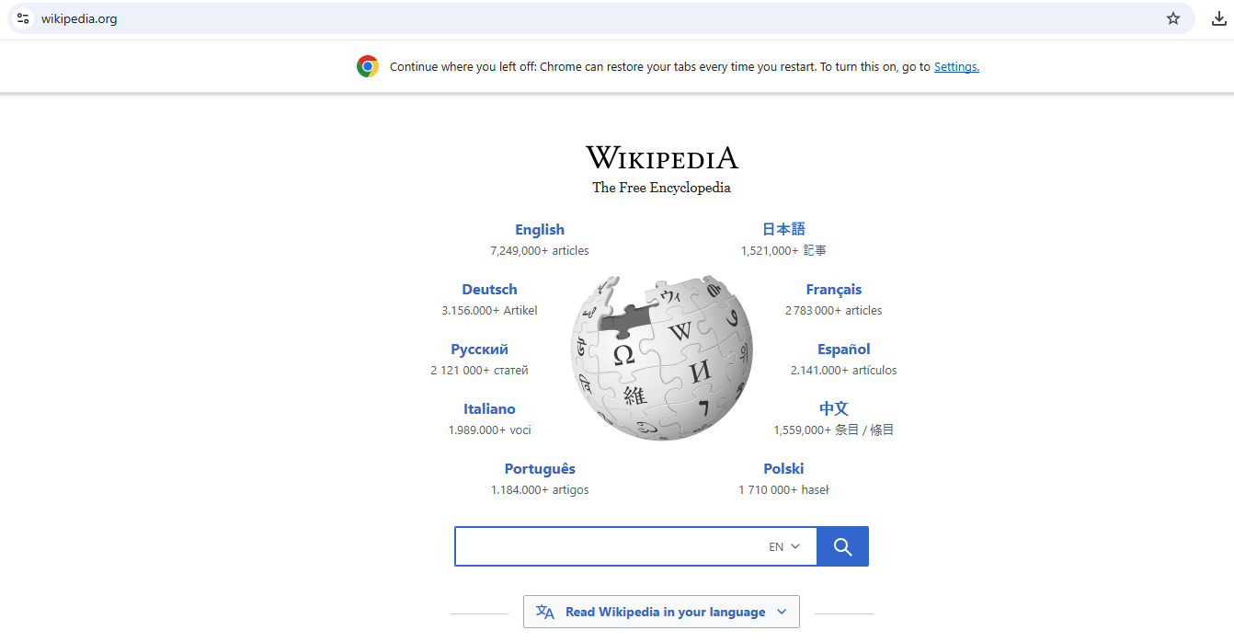

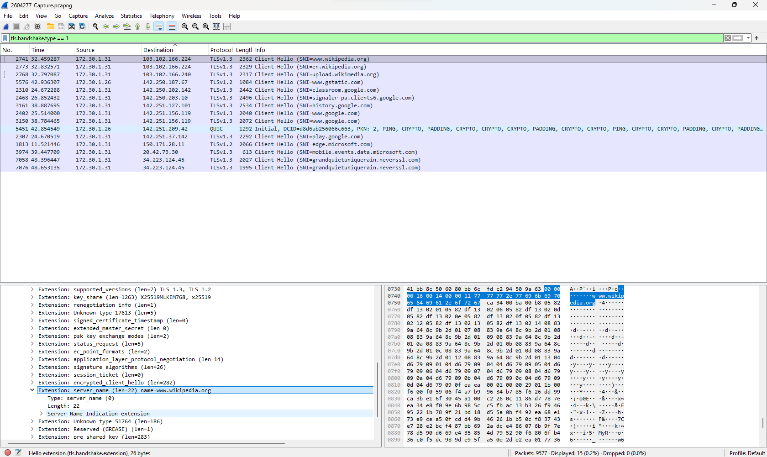
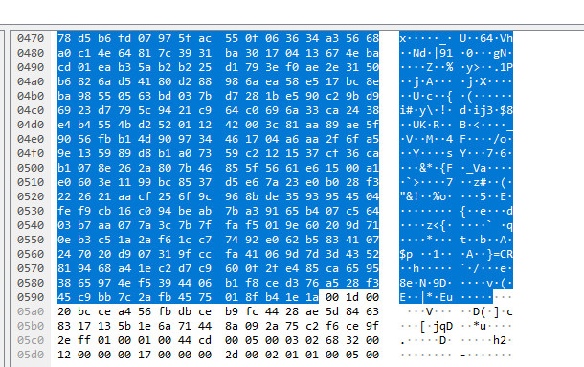

With HTTP, someone If intercept the request can read what’s inside the request, as it is without encryption. And with HTTPS, the website’s content and request are encrypted, thus interceptor wont be able to read what’s inside the conversations. HTTPS may reveal metadata’s, like IP address, domain names through SNI/DNS. HTTPS is important because encryption can protect sensitive information confidentiality, even if intercepted.

Task 5: TCP Handshake
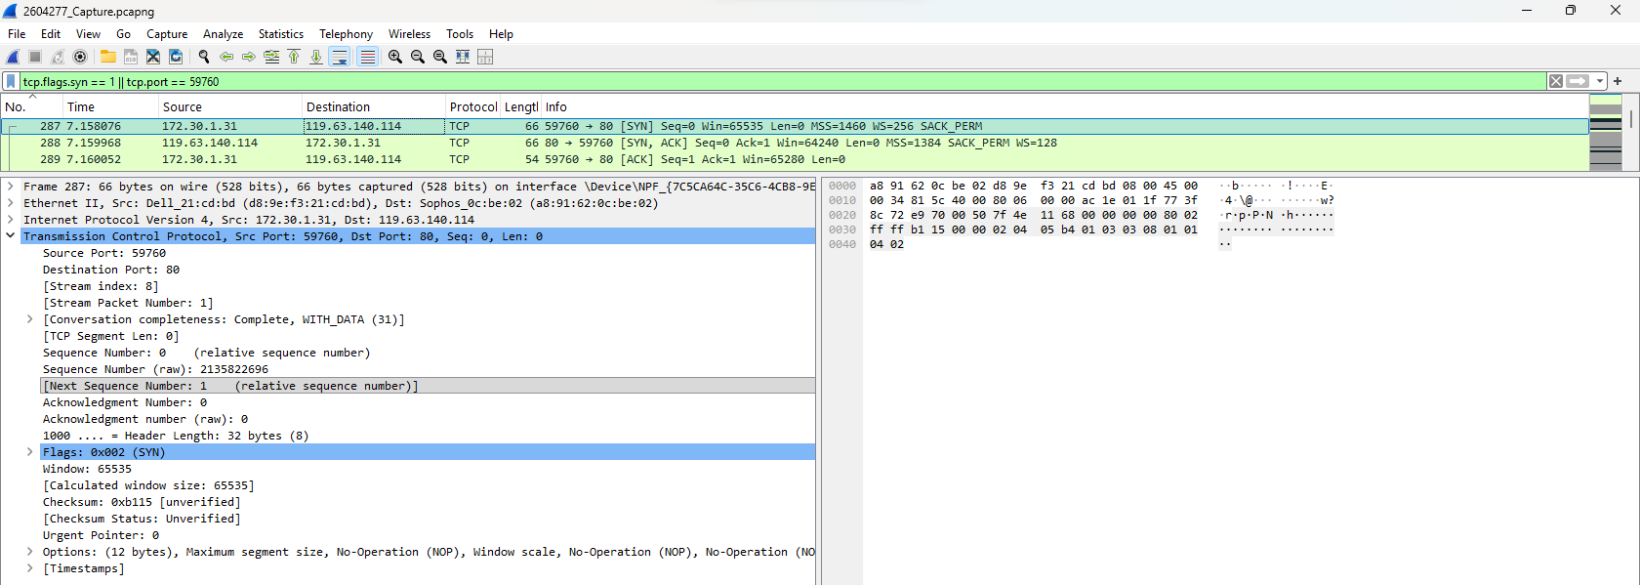
TCP flag | Packet no. | Source | Destination
SYN | 287 | 172.30.1.31:59760 | 119.63.140.114:80
SYN-ACK | 288 | 119.63.140.114:80 | 172.30.1.31:59760
ACK | 289 | 172.30.1.31:59760 | 119.63.140.114:80

Task 6: Privacy and Protection
DOMAIN / CONNECTION | LIKELY PURPOSE
Msedge.b.tlu.dl.delivery.mp.microsoft.com | Microsoft Edge downloads or update delivery
Edge.microsoft.com | Microsoft Edge browser services
Ohttp-relay-safebrowsing-chrome.google.fastly-edge.com | Likely related to Chrome Safe Browsing privacy relay services

Privacy risk:
Background connections reveals information of software and services I use, and also browsing activity, potentially.
Protection:
Using HTTPS & enabling DNS over HTTPS (DoH) encrypts website traffic & also DNS queries. A VPN also protects traffic from local network interceptors.

